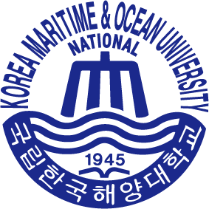
Application guideline for ‘2026 K-SAIL’

(For International Office of Partner Universities)

When you begin to accept the applications for our program, please refer to the following guidelines:

- Please use the information sheet on our program and application form to promote it to your students, faculty, and staff members. Collect all applications at your office and do not let the applicants send their applications directly to KMOU.
※ Please set the application deadline at your university before Dec 31st, 2026. Also note that the application and required document should be sent to our office no later than Jan 2nd, 2026(Korean local time).

- Once you begin collecting applications, please enter the applicant’s information into the attached file "#1. Applicants Data Sheet.xlsx".
※ Please make sure that each candidate has a different nomination ranking.
※ Please send all application documents in electronic format to email address below:
▶ Email: kmoukli@kmou.ac.kr, (Office Phone: +82-51-410-4774, Ms. Ah-Young JOH,
Korean Language Institute, Korea Maritime & Ocean University)
※ Checklist of Each Applicant’s Documents
- Application Form (“#2. Application Form.xlsx”)
- Recommendation Letter from the President of home university or the head of International Office of your university (Free Format)
- High School Graduation Certificate (with consular legalization or apostille)
- Bank balance certificate (minimum balance: equivalent to 8 million KRW; the applicant’s own bank account is acceptable)
* If the account is under a parent’s name, the applicant must also submit parent’s employment/income certificate and a family relationship certificate.
- Copy of Valid Passport
※ Application Document should be emailed by the International Office of your university.
Please note that we will NOT accept any applications sent individually.

- The maximum total number of attendants for this summer school is 22.
Each partner institution may nominate up to 3 applicants. KMOU will select final participants based on the nomination ranking provided by your office. In the event that a selected participant cancels, we will admit the next candidate based on your ranking.

- All application documents must be submitted by email no later than Jan 2nd, 2026(Korean local time).
(If any applicant, or staff member has questions, please feel free to add me on WhatsApp (+82-10-5584-8723) and contact me any time.)

- Please note that KMOU does not accept any professors, or staff members accompanying participants for the purpose of guidance for this program.

